Structure

🌟 Definition
# Source: AI Source: Provided by: [Data Path: Persons Table -> ID Column: 1, Name_En Column: Motasem Essam] -> From: [ChatGPT] on [5/30/2026]
Structure is the division of pure mathematics that studies patterns, relationships, operations, and abstract mathematical systems.
Rather than focusing on individual numbers or measurements, structure examines how mathematical objects relate to one another and how they behave under defined operations and rules.
It is the study of the organization and architecture of mathematics.

🎯 Purpose
# Source: AI Source: Provided by: [Data Path: Persons Table -> ID Column: 1, Name_En Column: Motasem Essam] -> From: [ChatGPT] on [5/30/2026]
- To study mathematical patterns and relationships
- To understand algebraic systems and structures
- To discover general rules that apply across many mathematical objects
- To develop abstract mathematical theories
- To provide a framework for modern mathematics

📚 Main Branches of Structure

1. Algebra
# Source: AI Source: Provided by: [Data Path: Persons Table -> ID Column: 1, Name_En Column: Motasem Essam] -> From: [ChatGPT] on [5/30/2026]
Studies symbols, variables, and mathematical relationships.
Topics
- Variables
- Equations
- Polynomials
- Functions
- Algebraic manipulation
Example
$$x+5=12$$

2. Linear Algebra
# Source: AI Source: Provided by: [Data Path: Persons Table -> ID Column: 1, Name_En Column: Motasem Essam] -> From: [ChatGPT] on [5/30/2026]
Studies vector spaces and linear transformations.
Topics
- Vectors
- Matrices
- Linear equations
- Eigenvalues
- Eigenvectors
Example
A system of linear equations represented by a matrix.

3. Abstract Algebra
# Source: AI Source: Provided by: [Data Path: Persons Table -> ID Column: 1, Name_En Column: Motasem Essam] -> From: [ChatGPT] on [5/30/2026]
Studies general algebraic structures.
Topics
- Binary operations
- Algebraic systems
- Structural properties
- Homomorphisms
- Isomorphisms

4. Group Theory
# Source: AI Source: Provided by: [Data Path: Persons Table -> ID Column: 1, Name_En Column: Motasem Essam] -> From: [ChatGPT] on [5/30/2026]
Studies mathematical structures called groups.
Topics
- Groups
- Subgroups
- Symmetry
- Permutations
- Group actions
Example
- Rotational symmetry of a square.

5. Ring Theory
# Source: AI Source: Provided by: [Data Path: Persons Table -> ID Column: 1, Name_En Column: Motasem Essam] -> From: [ChatGPT] on [5/30/2026]
Studies algebraic structures called rings.
Topics
- Rings
- Ideals
- Ring homomorphisms
- Polynomial rings

6. Field Theory
# Source: AI Source: Provided by: [Data Path: Persons Table -> ID Column: 1, Name_En Column: Motasem Essam] -> From: [ChatGPT] on [5/30/2026]
Studies algebraic structures called fields.
Topics
- Fields
- Field extensions
- Finite fields
- Algebraic numbers

🧩 Main Mathematical Objects Studied
# Source: AI Source: Provided by: [Data Path: Persons Table -> ID Column: 1, Name_En Column: Motasem Essam] -> From: [ChatGPT] on [5/30/2026]
- Variables
- Functions
- Polynomials
- Matrices
- Vectors
- Groups
- Rings
- Fields
- Algebraic structures

🔑 Fundamental Concepts
# Source: AI Source: Provided by: [Data Path: Persons Table -> ID Column: 1, Name_En Column: Motasem Essam] -> From: [ChatGPT] on [5/30/2026]
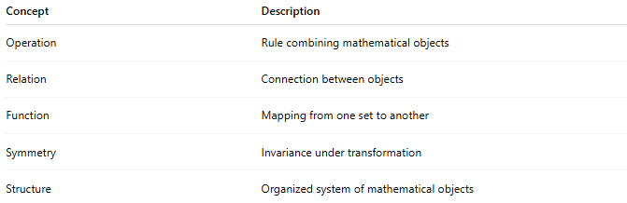
Concept | Description
Operation | Rule combining mathematical objects
Relation | Connection between objects
Function | Mapping from one set to another
Symmetry | Invariance under transformation
Structure | Organized system of mathematical objects

✏️ Example Questions
# Source: AI Source: Provided by: [Data Path: Persons Table -> ID Column: 1, Name_En Column: Motasem Essam] -> From: [ChatGPT] on [5/30/2026]
- What properties does a group have?
- How do matrices represent transformations?
- When are two structures equivalent?
- How do algebraic systems behave?
- What patterns exist in mathematical relationships?

🔗 Relationship to Other Divisions of Pure Mathematics
# Source: AI Source: Provided by: [Data Path: Persons Table -> ID Column: 1, Name_En Column: Motasem Essam] -> From: [ChatGPT] on [5/30/2026]
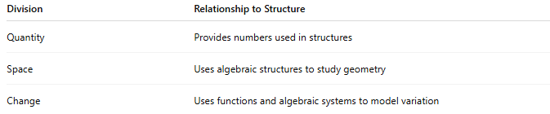
Division | Relationship to Structure
Quantity | Provides numbers used in structures
Space | Uses algebraic structures to study geometry
Change | Uses functions and algebraic systems to model variation

🧠 Simple Analogy
# Source: AI Source: Provided by: [Data Path: Persons Table -> ID Column: 1, Name_En Column: Motasem Essam] -> From: [ChatGPT] on [5/30/2026]
If Quantity studies the "things" of mathematics (numbers), then Structure studies how those things are organized and connected.
For example:
- Quantity asks: "What is the number?"
- Structure asks: "How do numbers relate to one another?"

🧭 Summary
# Source: AI Source: Provided by: [Data Path: Persons Table -> ID Column: 1, Name_En Column: Motasem Essam] -> From: [ChatGPT] on [5/30/2026]
Structure is the division of pure mathematics that studies patterns, relationships, operations, and abstract systems. Its major branches include algebra, linear algebra, abstract algebra, group theory, ring theory, and field theory. It provides the framework that organizes much of modern mathematics.

